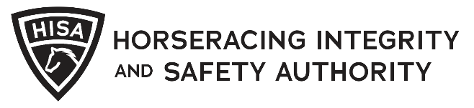
NOTICE OF STEWARDS HEARING
HISA Case Number: |  | Violation Date (mm/dd/yyyy):
State Tracking Number:
(optional)
Track Name: |  | Track HISA ID:
Served By: |  | Issued To:
HISA ID: |  | HISA ID:
Name: |  | Name:
VIOLATION INFORMATION
Rule Number(s) Alleged to Have Been Violated:

(If Applicable)
Race: | Horse Name: |  |  | Horse HISA ID:
Statement of Factual Basis of Alleged Violations (attach additional pages as necessary):

HEARING INFORMATION
Date (mm/dd/yyyy): |  |  | Time:
Physical Location:
--- OR ---
Web Meeting Link:

Signature of Person Serving Notice: |  |  |  |  | Date:
Recipient Signature: |  |  |  |  | Date:

