This document is provided as a sample/template that can be used to meet a portion of the Accreditation Requirements. Covered Persons may use their own documentation, use the sample template, or modify the sample template.
Document Type | Hazardous Weather Protocol
REg. Reference # | 2164
Racetrack | Insert Track Name
Version Number | 1.0

In anticipation of inclement weather events, the following policy and protocols will drive the decision-making process to either delay or cancel racing and training. The concern for the equine athletes, riders and all other participants’ safety serves as the main driver when these decisions are made, and decisions should always strive to err on the side of caution. Each weather incident is unique, and each will demand individual attention and analysis.
Purpose:
The Purpose of this policy is to:
- Assign responsibility in evaluating inclement weather events
- Assign responsibility in determining postponement and cancellations of racing and training
- Clarify the responsibilities and expectations of the stakeholders in an inclement weather event
- Designate an official responsible for enforcing any weather associated training delay

- Responsibility for evaluating inclement weather events:
It shall be the responsibility of the <insert names and titles> on any race or training days to:
- Obtain and monitor the forecast conditions for the day;
- Initiate the Hazardous Weather Protocol Policy when necessary, and ensure the provisions are appropriately observed, where applicable;
- Communicate with racetrack personnel regarding requirements;
- During the day monitor the weather provided by commercial weather service (e.g. Universal Weather Service);
- Throughout the day communicate and take advice from the Regulatory Veterinarian regarding current conditions and the condition of any horse;
- Consider whether modifying the racing program may provide improved conditions
Modification to the race day program may include advancement or delay in the races if it appears possible the extreme conditions might ease or can be avoided.

Summary Table of responsibilities and responsible person and contact information:
Activity | Name | Contact Info:
Monitor Daily Forecasts |  | Email:  Mobile:
Initiate Hazardous Weather Event
Monitor commercial weather service (same day)
Communicate and take advice from Reg Vets on conditions of any horse
Decision to postpone or cancel racing due to extreme conditions

Postponement and Cancellation:
In the event of a forecasted extreme weather condition as defined below the decision to cancel racing shall be made by <insert name and title> and confirmed by <insert name and title> by applying the Hazardous Weather Protocol Policy.
Notification of cancellation shall be communicated to the following:
- <Jockey’s Guild>
- <Stewards>
- <Other>

- Inclement Weather Events:
Severe or harsh weather environmental conditions that may include, without limitation:
- High Temperatures or Heat Stress Index
- Low Temperatures or Wind Chill
- High Winds
- Lightning
- Precipitation
- Air Quality
- Fog/Visibility

- High Temperatures or Heat Stress Index:
Heat Stress Index (HSI) is calculated by adding the current temperature (in Fahrenheit) and the relative humidity (in % RH). For example, if it is 77 degrees out and the relative humidity is 65%, added together the heat index is 142.

180 or more:
The horse has no natural means to cool off, and the rider/handler must provide aggressive cooling.
150 or more:
The horses cooling mechanisms are reduced and supplemental cooling must be provided.
130 or more:
The horse’s cooling is mildly diminished and some horses may need assistance.
Less than 130:
The horse can cool itself.

Heat mitigation precautions should be in place whenever HSI is expected to exceed 130:
- strategically placed hoses for both before and after the race;
- ice buckets with sponges in the unsaddling area;
- ice in coolers in ambulances/ track veterinarian vehicles; and
- additional monitoring of horses post-race for heat-related problems.
In the event HSI exceeds 160, any determination to proceed with racing or training requires the approval of the stewards based upon a recommendation from Regulatory Veterinarian.

No training or racing shall be permitted when HSI exceeds 175.

Wet Bulb Globe Temperature Index (WBGT): a measure of the heat stress in direct sunlight, which takes into account temperature, humidity, wind speed, sun angle and cloud cover. Currently, the Federation Equestrian International (FEI) uses the WBGT. If the WBGT index is above 91.4, serious consideration to cancel or postpone racing/training should be taken. See link for more details.

- Low Temperatures or Wind Chill
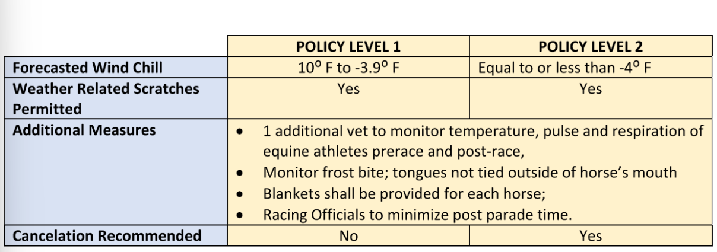

- HIGH WINDS
The racetrack may install an anemometer near the racing surface at the approximate height of the rider
.
Wind speed threshold: Sustained 38 mile per hour and/or gusts over 50 miles per hour –temporarily suspend Racing and Training.
d) LIGHTNING
(Possible answer – modify to meet the procedures at your track) We have installed a real-time lightning detector and warning system that has been independently and objectively verified and subscribe to a commercial weather service (e.g. Universal Weather Service) that provide lightning detection services. The detection service includes strike distance and radius notifications in order to provide lightning delay decision-making. The lightning detection information is monitored by the Track Superintendent, or his staff during training and racing hours. This information is made available to race track management and stewards at all times.
Suspension of Racing and Training:
When lightning is detected within an 8-mile radius of the racetrack the following actions will take place:
• Track Superintendent shall notify racetrack management immediately
• Racetrack management will suspend racing and training
• Racetrack Management will notify the Stewards
• Alert all participants to seek shelter

Resume Activity:
Racing and training activities may resume 30 minutes after the last lighting strike within an 8 mile radius of the racetrack as indicated by the lightning detection service.

e. PRECIPITATION
When precipitation is forecasted the Track Superintendent will analyze the following:
- Total amount of rainfall;
- Duration of rainfall;
- Predicted timing relative to training or racing.
The Track Superintendent will make a determination if the track needs to be sealed and or floated.
Any decision to race on a sealed of floated track will be made based upon a decision by the Track Superintendent that in his or her professional opinion the resulting track surface is safe for the conduct of races. That decision shall also provide that the conduct of racing will not jeopardize the safe conduct of racing or training on days subsequent to the inclement weather event.
When the rain event has ended the Track Superintendent will determine the optimal time to harrow the track using the float rake or conditioning harrows. High speed workouts may resume only when approved by the Track Superintendent.
No Racing or Training shall be permitted on any surface deemed unsafe by the Track Superintendent or Board of Stewards.

Turf Track:
During a rain event the Turf Track Supervisor will continually monitor turf course to determine the amount of moisture in the track by using the following methods:
- Visual inspections;
- Walking the course;
- Using a GoingStick or probe.
If the Turf Track Supervisor determines there is too much moisture in the track and could be unsafe, he will notify the General Manger immediately. The decision to take races off or leave races on the turf shall be made by the General Manager of the association subject to confirmation by the Board of Stewards.

- Air Quality
The U.S. Air Quality Index (AQI) is an index developed by the Environmental Protection Agency to measure air quality. The higher the number (1-500), the higher the level of concern. The projected AQI for a given location can be found at https://www.airnow.gov/. Tracks may also utilize on-site AQI monitors.
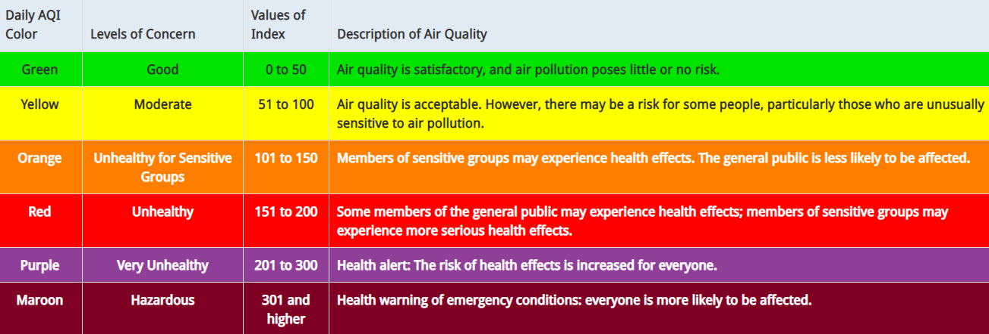
AQI=100-150
Monitor the facility daily if the AQI consistently reaches 100 and there is cause for concern in the local environment, including the presence of a wildfire in the area.
AQI= 150-174
Closely monitor the facility and may limit training to jogging and/or jogging and gallops only and be prepared to take further action if conditions worsen.
AQI = 175+
Restrict activity at the track, including but not limited to:
- Canceling live racing (if applicable);
- Canceling official workouts; and
- Prohibiting galloping, breezing or anything more strenuous than a jog.

- Fog/Visibility
In the event of impaired visibility, the Board of Stewards, the GM of the association and the Jockeys’ Guild representative shall meet to determine if the races should be cancelled or delayed. If any entity in the aforementioned group believes that the visibility is compromised such that racing would be unsafe, then the races shall be cancelled or postponed. If the evidence indicates that visibility will improve, the races may be delayed for a period not to exceed one hour, at which time the group will meet again to decide if the races can safely continue.

