Appendix 1- Training / Non-Racing Injury Reporting Form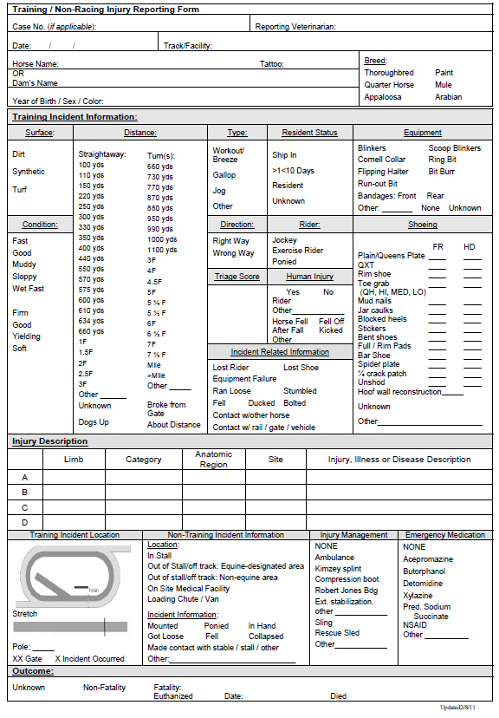
Race Injury Reporting Form
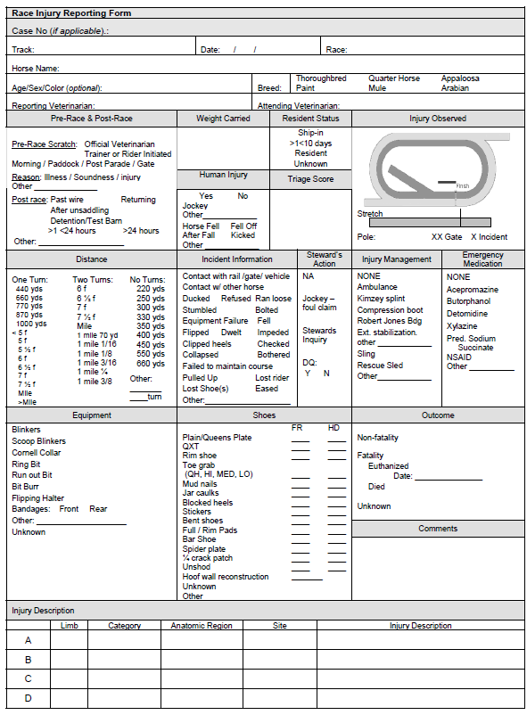
*forms provided by The Jockey Club

